**1. What exactly is []?**

Empty list

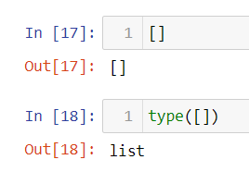

**2. In a list of values stored in a variable called spam, how would you assign the value 'hello' as the third value? (Assume [2, 4, 6, 8, 10] are in spam.)**

**Let's pretend the spam includes the list ['a', 'b', 'c', 'd'] for the next three queries.**

spam[2]=”hello”

**3. What is the value of spam[int(int('3' * 2) / 11)]?**

‘d’

Because int(int(‘3’*2)/11) = 3 and span[3]=’d’

**4. What is the value of spam[-1]?**

‘d’ //last element of list

**5. What is the value of spam[:2]?**

[‘a’,’b’]

**Let's pretend bacon has the list [3.14, 'cat,' 11, 'cat,' True] for the next three questions.**

**6. What is the value of bacon.index('cat')?**

1

**7. How does bacon.append(99) change the look of the list value in bacon?**

[3.14, 'cat', 11, 'cat', True, 99]

**8. How does bacon.remove('cat') change the look of the list in bacon?**

[3.14, 11, 'cat', True, 99]

**9. What are the list concatenation and list replication operators?**

List concatenation operator is +

List replication operator is *

**10. What is difference between the list methods append() and insert()?**

append() inserts element at the end of the list whereas insert() inserts the element at a specific value in the list.

Ex.

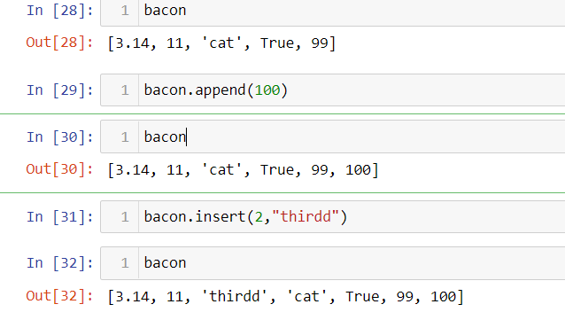

**11. What are the two methods for removing items from a list?**

pop() and remove()

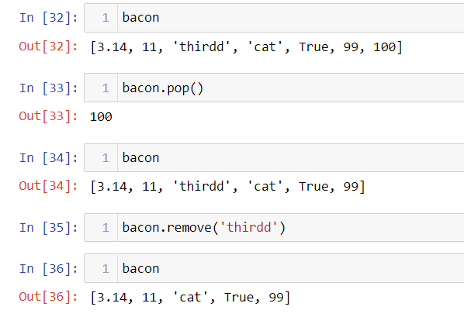

**12. Describe how list values and string values are identical.**

Len() can be used with both data types. Indexes and slices can be performed to both. Both cancatenate and replicate in same way.

**13. What's the difference between tuples and lists?**

List are mutable wheras tuple are immutable, i.e., values in tuples can not be changes once created.

**14. How do you type a tuple value that only contains the integer 42?**

(42,)

**15. How do you get a list value's tuple form? How do you get a tuple value's list form?**

Using tuple() and list method().

Ex.

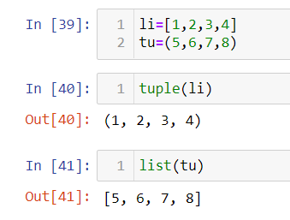

**16. Variables that "contain" list values are not necessarily lists themselves. Instead, what do they contain?**

They actually contain reference to the list values.

**17. How do you distinguish between copy.copy() and copy.deepcopy()?**

copy.copy(x) Return a shallow copy of x.

copy.deepcopy(x[, memo]) Return a deep copy of x.

